|  |
| --- |
| FAST National University |
| **Lab 7** |
|  |

**Computer Organization and Assembly Language**

|  |  |
| --- | --- |
| **Student Name** | EISHA AMIR |
| **Registration #** | 21L-5255 |
| **Instructor** | Hazoor Ahmad |
| **Class** | CS3 |
| **Section** | H |
| **Semester** | Fall 2022 |

Fast School of Computing

FAST-NU, Lahore, Pakistan

# Activity 1

## **Assembly Language Code**

[org 0x0100]

jmp start

message: db 'hello'

length: dw 5

message1: db 'hi'

length1: dw 2 ;

message2: db 'bye'

length2: dw 3

clrscr: push es

push ax

push di

mov ax, 0xb800

mov es, ax

mov di, 0

nextloc: mov word [es:di], 0x0720

add di, 2

cmp di, 4000

jne nextloc

pop di

pop ax

pop es

ret

delay: push cx

mov cx, 0xFFFF

l1: loop l1

mov cx, 0xFFFF

l2: loop l2

pop cx

ret

printstr: push bp

mov bp, sp

push es

push ax

push cx

push si

push di

mov ax, 0xb800

mov es, ax

mov al, 80

mul byte [bp+12] ;

add ax, [bp+10] ;

shl ax, 1

mov di, ax

mov si, [bp+6] ;

mov cx, [bp+4] ;

mov ah, [bp+8] ;

nextchar: mov al, [si]

mov [es:di], ax

add di, 2

add si, 1

call delay

loop nextchar

pop di

pop si

pop cx

pop ax

pop es

pop bp

ret 10

start: call clrscr

mov ax, 10

push ax

mov ax, 30

push ax

mov ax, 7

push ax

mov ax, message

push ax

push word [length]

call printstr

mov ax, 20

push ax

mov ax, 35

push ax

mov ax, 14

push ax

mov ax, message1

push ax

push word [length1]

call printstr

mov ax, 15

push ax

mov ax, 10

push ax

mov ax, 0x05

push ax

mov ax, message2

push ax

push word [length2]

call printstr

mov ax, 0x4c00

int 0x21

## **Debugging Screenshots**

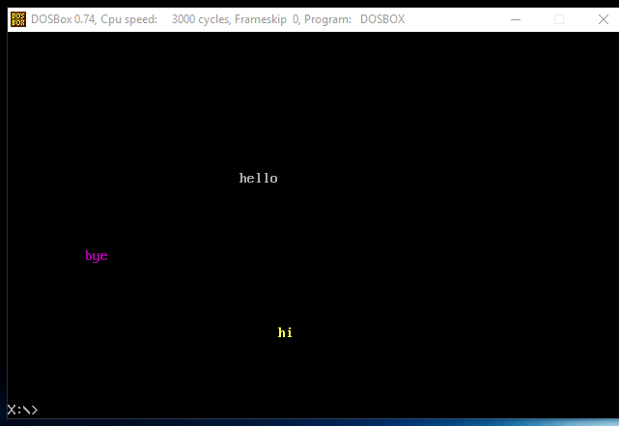

# Activity 2

## **Assembly Language Code**

[org 0x0100]

jmp start

top: dw 10

bottom: dw 15

left: dw 20

right: dw 60

start:

call clrscr

push word [top]

push word [bottom]

push word [left]

push word [right]

call drawrect

end:

mov ax, 0x4c00

int 21h

clrscr:

mov ax, 0xb800

mov es, ax

xor di,di

mov ax,0x0720

mov cx,2000

cld

rep stosw

ret

drawrect:

push bp

mov bp, sp

pusha

mov al, 80

mul byte [bp + 10]

add ax, [bp + 6]

shl ax, 1

mov di, ax

push di

mov ah, 7

mov cx, [bp + 4]

sub cx, [bp + 6]

push cx

mov al, '-'

loop1:

rep stosw

pop bx

pop di

push bx

dec bx

shl bx, 1

add di, 160

mov cx, [bp + 8]

sub cx, [bp + 10]

sub cx, 2

mov al, '|'

loop2:

mov si, di

mov word [es:si], ax

add si, bx

mov word [es:si], ax

sub si, bx

add di, 160

loop loop2

pop cx

mov al, '+'

loop3:

rep stosw

return:

popa

pop bp

ret 8

## **Debugging Screenshots**

